Abstract: Nowadays population growth increased exponentially and health diseases also increase parallel. Because the persons do not give important about the body conditions due time allocation and highly complexity of getting appointment with doctor and proper treatment. In this paper deals with the problem by using an android application in which is placed in mobile phone. It is used to monitor all appointment as well as deals with doctors with user’s own hand. This mobile application highly useful for the mankind. Compare with the other mobile application how overcome those problems without need going hospital and save money and time both.
HUMAN HEALTH MONITORING
MOBILE PHONE APPLICATION BY
USING JAVA PROGRAMING
LANGUAGE BASED ON ANDROID
S.M.Irfan Rana
Id: 161-15-7073
Irfan15-7073@diu.edu.bd
Daffodil International University
Keyword: programing language(JAVA), Emulator, Android phone, other devices.

Introduction
This is a java application named “EASY HOSPITAL”. The people of all classes can use our application. This chapter highlights the result of the project and the snapshots for each of the activities are shown along with the discussion of each activity describing it’s working. Each snapshot describes every single step of the easy hospital application. Two main activities as well as options provided to the users in each activity such as menu options and the activities which are created on the click of these options are also shown and described in brief. Using this application people can find information of hospital as well as information of doctors and specialist. User also can store information of any doctor.

The main features
The main features of our application are as follow,
- Login
- Home
- Hospital list: Here user can add many hospital name with which user want to contact.
Like as-
- Hospital 1
- Hospital 2
- Hospital 3

- Doctor Information: Here user can control this app. User can update all information, User can remove any data whatever he/she add into it. Also user can call doctor and can make a contact or appointment.
- Update
- remove
- call
- Home

Progress done
All features in our project almost implemented. The features shown in some screenshots as follow,
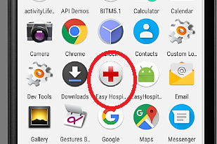
Here is the icon of our application which user can see in red circle. I think this icon is totally different from any other icon of this type of applications. It will be easier to user to find our application.
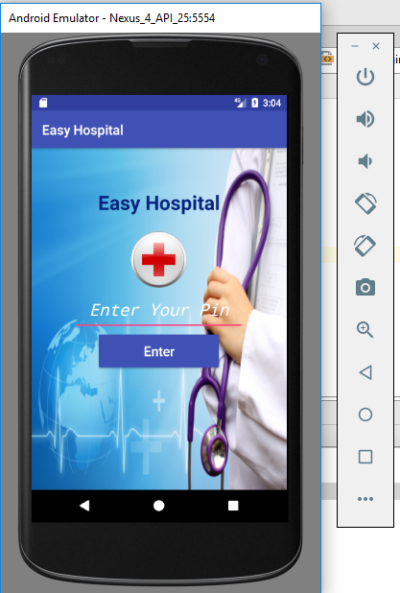
This is login page. To enter into this application user must log in.
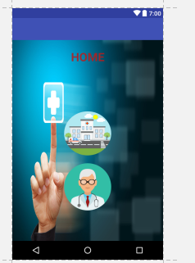
After log in it will show home page. In this page there will two options.
- Hospital List
- Doctor Information
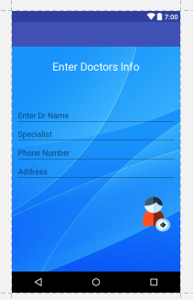
Here user can store information of any doctor what user want.

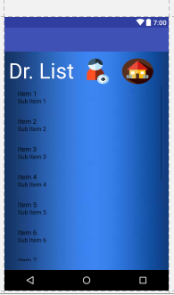
In this section user can see all doctors list what are stored by user. There is also a home option. User can return home from here.
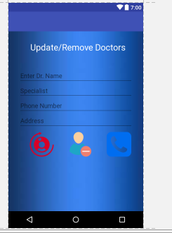

We can see here this is a welly designed user interface. There are two sections in this interface. First of all the editing option. Here user can edit any doctor’s information and can save it. In another section there are three icons. Using those icons user can remove doctor’s information whatever user saved before. Also user can call the doctor to make any contact or appointment easily. I think those systems to use this application are very easy to user.

prospects Future
In future we will implement some another features like as GPS, map, ambulance service, online appointment system etc. After implementing all those features this application will be a proper application in medical field as well as it’ll be very helpful for the mankind and easier to use to random ages of people.

Conclusion
This is a very important application. It will help people to get any medical service easily. It will reduce tension of people to finding hospital and doctor with a huge time. It will make a patient very closer to hospital and doctors. So we hope everyone will like our application and use it with satisfaction.

References
- Google.com
- Youtube.com
- https://www.slideshare.net
- https://www.slideshare.net/tilottama_deore/2013-ieee-human-health-monitoring-mobile-phone-application-by-using-the-wireless-nanosensor-based-embedded-system
- https://www.youtube.com/watch?v=evT5uvDMuSc

Get me in GitHub
https://github.com/smrana

..……… Thank You ………...

